Phase Change Materials (PCM) Modeling in MATLAB

Pascal Stevens

Sophomore, Mechanical Engineering

Spring 2025, Undergraduate Research Report

ABSTRACT

This research project explores the use of Phase Change Materials (PCMs) for improving building insulation through time-dependent thermal modeling in MATLAB. A composite wall structure—comprising limestone, PCM, and drywall—was modeled to simulate heat transfer and energy storage under realistic daily temperature cycles using historical 2023 weather data from the National Renewable Energy Lab. The model applies Fourier’s Law and thermal resistance analogies to calculate heat flux and track the PCM’s phase changes at one-second intervals over a 24-hour period.

Custom logic was implemented to simulate melting and freezing behavior based on latent heat exchange, enabling the system to transition between solid, liquid, and phase-change states. The program also incorporated data import functions for selecting different PCMs and climate conditions, allowing for broad comparative analysis.

Results demonstrated that PCM-enhanced walls can significantly reduce peak internal temperatures and store up to 14,000 kJ of thermal energy per day—outperforming traditional insulation in both energy retention and passive cooling. While simplified for clarity and performance, the model provides a strong foundation for further analysis of PCM applications in building design, including energy cost savings and environmental impact. Future work may scale this model to whole-building simulations and integrate financial and material optimization strategies.

1| INTRODUCTION

This research project looks to create various MATLAB models to simulate building heat flow and energy storage between within the interior and exterior walls of buildings. Specifically, we are looking into how different types of Phase Change Materials (PCMs) change the heat flow and energy storage, and which would be most effective in different climates. This flow of energy is particularly important, as studies estimate that in the United States, 27.6% of all energy usage was dedicated to heating or cooling residential and commercial spaces. Through our models we hope to identify which commercially available PCMs can most effectively passively store and/or reduce the amount of thermal energy entering buildings in various climates, thus reducing the strain on building climate control. This reduction will result in reduced energy usage, thus providing both energy savings for the building operator, and reducing the overall carbon footprint of the building, sometimes up to as much as 40%.

2| Scope and Methodology

In this project, we had the following goals for the PCM models:

1. Accurately model the heat flux and total heat passed through a composite wall structure.
2. Create a time-dependency factor that could model how this heat flux changed throughout the day.
3. Import historic temperature and weather data from various US cities and incorporate it into the models.
4. Import various PCM properties and incorporate different composite wall structures into the models.
5. Provide nice, readable data and graphs of the findings, as well as important summary statistics.

2.1 Accurate Time-Dependency Heat Flux Model

The fundamental equation of this research is Fourier’s Law of thermal conduction,

Q = -kA $\frac{dt}{dx}$ ($SEQ Equation \backslash * ARABIC$ $1$)

Which in this case is equation to,

Q = $\frac{Toutside-Tinside}{\sum{Resistance}}$ (2)

The resistance is the thermal conductance and resistance formula,

R = $\frac{∆x}{k*A}$ (3)

where $∆$ x is the length of the resistor network in question, k is the thermal conductivity of the material, and A is the surface area of the wall in question. This research took advantage of the fact that for composite wall structures, heat flows through the composites like electric charge through resistors, and thus the total resistance of the wall is equal to the sum of each individual component’s resistance. We imagined our composite wall model to look something similar to this:

**Figure 1** Here is a hypothetical composite wall we are modeling. The PCM is sandwiched between limestone and drywall. When the temperature outside is greater than the temperature inside, heat will flow across the system from left to right. When the temperature outside is less than the temperature inside, it will flow from right to left.

In the model, the program iterates and calculates the total amount of heat gained, lost, or stored by the PCM each second over the given timeframe (in our model it is currently set to 24 hours). Throughout the 24-hour time period, the program imports the temperature from the weather data every 5 minutes, which matches the most detailed downloadable data accessible from NREL. For our model, we assumed ideal conditions and focused on the principle that all heat passed into the PCM would be stored or released as latent heat during a phase change, thus it would be impossible for solid or mixture of PCM to exist above the melting point, and liquid or mixture of PCM to exist below the melting point. We also assumed the PCM would melt and freeze in a uniform, linear fashion from the side that the temperature change was taking place (ie: if Toutside > Tmelt, we assumed the PCM was melting linearly from the side closest to the outside temperature. To ensure code was written to cover all unique bases of heating and cooling, the following chart was used:

|  |  |  |  |
| --- | --- | --- | --- |
|  | Tpcm < Tmelt | Tmelt = Tpcm | Tpcm > Tmelt |
| PCM solid | solid warming | PCM phase change | IMPOSSIBLE |
| PCM solid & liquid | IMPOSSIBLE | PCM phase change | IMPOSSIBLE |
| PCM liquid | IMPOSSIBLE | IMPOSSIBLE | Liquid warming |

On the left is each possible state of matter within the PCM, and on the top is each possible temperature situation.

The model used dual resistor networks to calculate the change in temperature of the PCM each second for the solid and liquid warming stages. Using the above formulas, the total heat passed into the PCM through the limestone was calculated, and then the total heat passed out of the PCM on the right side was calculated. The difference in this, Qnet, was the heat stored in the PCM. The temperature change of the entire wall was then calculated using the equation

q = mc∆T (3)

with the respective mass and specific heat capacity of each material in the composite wall considered.

For the melting and freezing stages, it was known that Tmelt = Tpcm must be true. Therefore, we use the same equations as before and find that if the calculated Qnet is positive, then the PCM is melting, and if Qnet is negative, the PCM is solidifying. We then find out how much of the PCM has changed and adjust the geometry before continuing with the model. When the PCM has completed its phase change to fully solid or fully liquid, it will revert to either of the first two stages previously discussed until the temperature change between the inside and outside temperatures pushes the PCM back into a phase change. It is this ability to move between the phase change and whole wall modeling systems that allows us to confidently simulate different PCM scenarios for entire 24-hour cycles.

2.2 Weather and PCM Data Importation

Weather data (of which we only used temperature right now) was download for each specific city for the year of 2023 from the United States National Renewable Energy Lab website, which provides complete weather records of any major American city updated every five minutes. This data was downloaded into excel and organized in a way where a function getCityWeatherData was written to identify the city and date the user inputs into the system. It will then import the required data from the excel spreadsheet and update the temperature in the calculation every five minutes in the model loop.

PCM data importation came from several research papers and online databases, particularly from *Ceee-pcm-explorer* (see citation below for a full list of all resources). Each important characteristic was imported to a large excel document, and the function getData was used to import the data requested by the user from the spreadsheet to the model.

In each of these cases, additional city weather data and PCMs can be easily added to the excel documents and then called directly from the program, removing the need to manually adjust code within the program.

The program defines the rest of the wall composite as a thick layer of outer limestone and a thin interior layer of drywall sandwiching the PCM. These material’s characteristics are defined at the top of the program and can be easily adjusted from within the program, though there is currently no spreadsheet or user assistance to do so without directly modifying the MATLAB code.

2.3 Graphs and Summary Statistics

Throughout the model, many statistics were updated and saved on a minute-by-minute basis to allow accurate monitoring and discussion of overall trends throughout the chosen period. These data included things like energy stored, temperature of the PCM, rate of change of the temperature of the PCM, outside temperature, and the ratio of solid to liquid in the PCM.

These data points were saved in arrays and summarized on the summary statists page at the end of the simulation. Additionally, the data was monitored and graphed on the summary slide, with graphs for the percent melted and temperature of the PCM, the outside temperature, and the heat flux through the walls. These graphs are critical, as they show the overall trends of the models and allow comparison between results of different models in different PCMs.

3| Results and DiscussioN

3.1 Summary of Key Results and Implications

This work resulted in a MATLAB code that could simulate and show results of different PCMs in composite wall constructions.

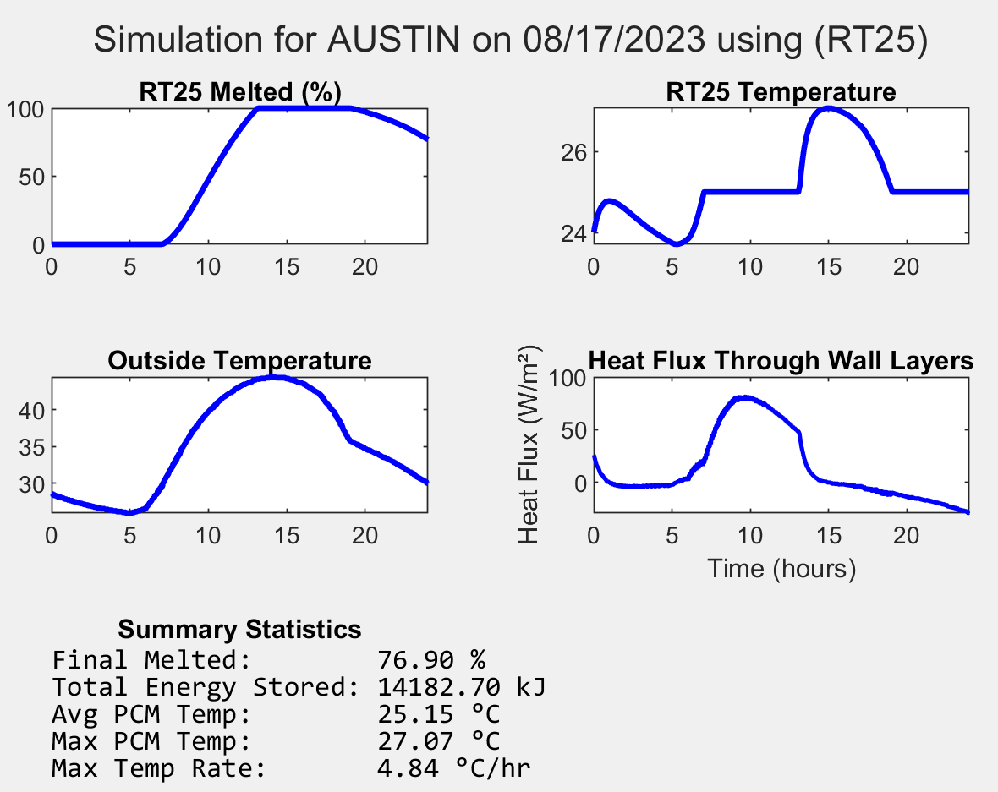 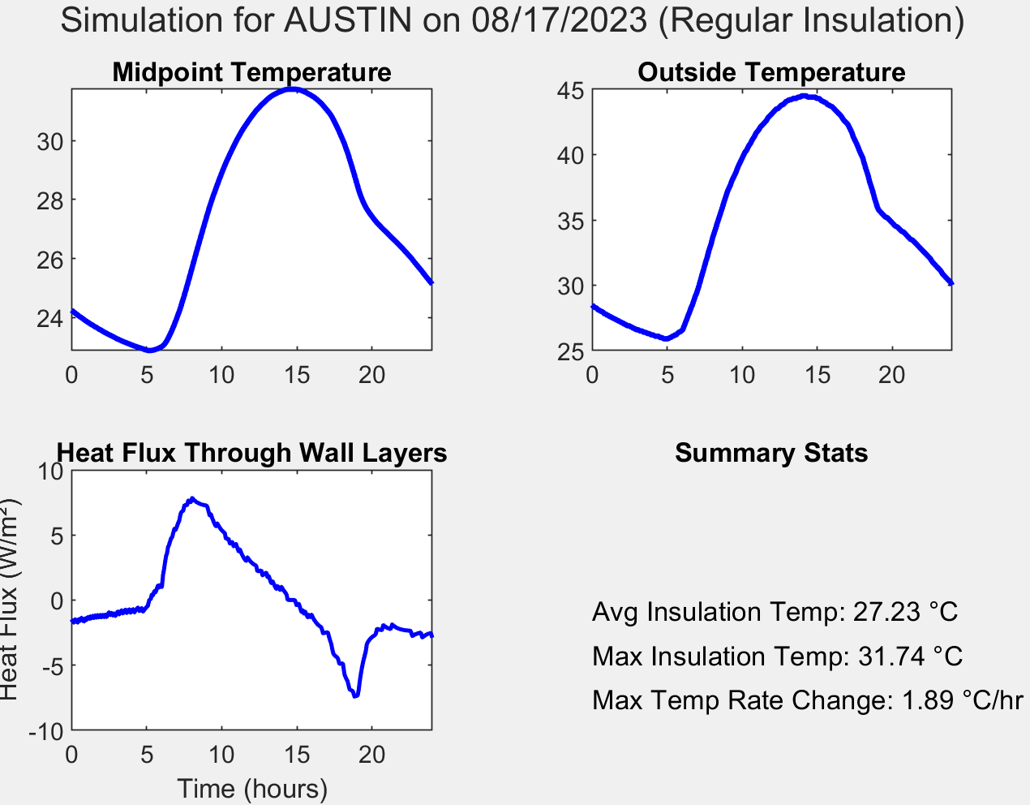

**Figure 2 (left)** displays the model results of a composite wall structure using RT25 as a phase change insulator for an August day in Austin, Texas. **Figure 3 (right)** shows a simulation of the same day with a traditional insulation material.

When compared against traditional insulation models, the model we built highlights the difference in energy storage and temperature difference within the walls. In the figures above, the PCM model showed how effective a PCM could be, saving over 14000 KJ of energy in its phase change solution, and topping out at a temperature of 27 degrees C. Regular insulation, however, topped out at almost 31 degrees C and stored no thermal energy, demonstrating the clear advantages of PCM insulation in some situations.

This model also worked to find which PCMs are most effective in different climates, as one can compare the results of one PCM modeling to another. Local weather data also makes a difference, as areas with large climate swings (such as Austin) are more difficult to find a one-size-fits-all PCM that can handle several different temperature extremes.

3.2 Challenges Faced and Limitations of the Work

Some challenges that were faced during this project was how to break down a system of insulation and heat exchange into simple enough terms that it could be modeled with MATLAB. Our solution to this was the analogy to the resistor network as discussed above, which helped simplify and create the basis of logic for our research.

Throughout the coding and implementation, we frequently ran into syntax and logic errors while learning to use MATLAB and creating complex mathematical models within the MATLAB frameworks. At times when our MATLAB skills were limited, we would employ LLMs (namely ChatGPT) to assist in the development and improvement of the code. While not writing any code for the project, ChatGPT assisted in improving readability, performance, and debugging speed of our research.

Lastly, this model is very simplistic, with many assumptions given. This is because in this vein of research many variables are at play in every aspect – weather is dependent on far more than just surface temperature, composite material temperatures deviate from expected values, the PCM does not linearly solidify and freeze. Additionally, other factors like the amount of PCM, dimensions of the wall, cost, etc. play an important role in the implementation of PCM as a true insulator. However, to keep the model simple and create a working proof of concept, we decided to simplify and standardize as many variables as possible and begin to add in more variables to make it more realistic as the simulation progresses.

3.3 Self-Reflection

Throughout the duration of this project, I learned a considerable amount about MATLAB syntax and optimization techniques for code and methods being called. I also gained an understanding for basic heat transfer laws and models, and how to implement those in professional and academic settings. Knowing this now, I would have changed our initial approach to the project to use a time-based method of heat transfer rather than a straight energy calculation. While I understand it was necessary to compare different materials and get a feel for the basics of MATLAB, I believe we lost some time by missing the main point of our research goal.

I am, however, proud of the model we have created. The results are a promising outcome for the incorporation of PCMs into building spaces, and through additional work I believe it is possible to show additional monetary and environmental incentives for PCM integration.

Conclusions

By the conclusion of the semester, this project was able to quantitively model several different PCMs using real climate data from a few different cities and allowed for comparison of energy storage and insulation efficiency between traditional wall insulation and PCM insulation. The model results show a clear advantage of using PCMs as wall insulation at certain temperatures, with energy storing and saving benefits being potentially significant.

This research could go several ways in the future. Some of these that are of interest to us are identifying which PCMs could have the most benefit in different climate areas, using our existing models to compute exact energy savings by PCM incorporation by including heating and cooling cost savings in local energy markets, and adapting this model into larger building models to see total thermal effects of PCMs on large structures.

REFERENCES

*16. 4 thermal resistance circuits*. (n.d.). Retrieved April 24, 2025, from https://web.mit.edu/16.unified/www/FALL/thermodynamics/notes/node118.html

Ahmad, A., & Memon, S. A. (2024). A novel method to evaluate phase change materials’ impact on buildings’ energy, economic, and environmental performance via controlled natural ventilation. *Applied Energy*, *353*, 122033. https://doi.org/10.1016/j.apenergy.2023.122033

Biswas, K., Lu, J., Soroushian, P., & Shrestha, S. (2014). Combined experimental and numerical evaluation of a prototype nano-PCM enhanced wallboard. *Applied Energy*, *131*, 517–529. https://doi.org/10.1016/j.apenergy.2014.02.047

*Ceee-pcm-explorer*. (n.d.). Retrieved April 24, 2025, from <https://ceeeweb.umd.edu/pcmapp/>

*Frequently asked questions (Faqs)—U. S. Energy information administration(Eia)*. (n.d.). Retrieved May 23, 2025, from https://www.eia.gov/tools/faqs/faq.php?id=86&t=1

Gbekou, F. K., Belloum, R., Chennouf, N., Agoudjil, B., Boudenne, A., & Benzarti, K. (2024). Thermal performance of a building envelope including microencapsulated phase change materials (Pcms): A multiscale experimental and numerical investigation. *Building and Environment*, *253*, 111294. https://doi.org/10.1016/j.buildenv.2024.111294

Gurgenc, E., Gur, M., Cosanay, H., Gurgenc, T., & Oztop, H. F. (2025). Effects of position of semi-circular body on melting of a novel B4C/RT44HC PCM nanocomposite in a closed space. *Case Studies in Thermal Engineering*, *65*, 105628. https://doi.org/10.1016/j.csite.2024.105628

Kuznik, F., David, D., Johannes, K., & Roux, J.-J. (2011). A review on phase change materials integrated in building walls. *Renewable and Sustainable Energy Reviews*, *15*(1), 379–391. https://doi.org/10.1016/j.rser.2010.08.019

Nizovtsev, M. I., & Sterlyagov, A. N. (2024). Effect of phase change material (Pcm) on thermal inertia of walls in lightweight buildings. *Journal of Building Engineering*, *82*, 107912. https://doi.org/10.1016/j.jobe.2023.107912

*Nsrdb*. (n.d.). Retrieved April 24, 2025, from https://nsrdb.nrel.gov/

Prieto, M. M., Suárez, I., & González, B. (2017). Analysis of the thermal performance of flat plate PCM heat exchangers for heating systems. *Applied Thermal Engineering*, *116*, 11–23. https://doi.org/10.1016/j.applthermaleng.2017.01.065

Weinläder, H., Beck, A., & Fricke, J. (2005). PCM-facade-panel for daylighting and room heating. *Solar Energy*, *78*(2), 177–186. https://doi.org/10.1016/j.solener.2004.04.013